Types of Operating Systems

Bhavneet Soni

Author’s Note

In 1981, referring to computer memory, Bill Gates said, “640K (roughly 1⁄2 of a megabyte) ought to be enough for anybody.” Now consider this Computer used to write this report has a memory of 32 Giga Bytes and still can do with more. Computer memory has come a long way from vacuum tube based memory that could handle only a few bits of data a time, to terabytes of data in your palm. In addition, the physical size of memory has reduced from machines housed in big halls to small chips in your phones. In this report, we talk about some of the technological advancements that have taken in memory technologies over the years and future trend.

**Types of Operating Systems**

Operating system can be seen as a software abstraction over hardware

Types

1. Batch Operating
2. Time Sharing
3. Distributed
4. Network Operating System
5. Real Time operating
   1. Hard Real time
   2. Soft real time

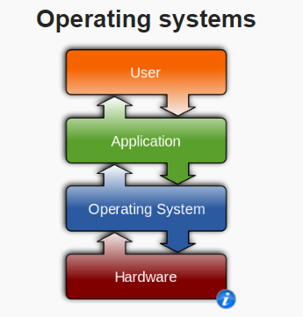

Figure Wikkipedia

References

InformationQ. (2015, May 19). *Two types Computer Memory | Primary and Secondary Memory |*. Retrieved from http://www.informationq.com: http://www.informationq.com/computer-memory/

Mearian, L. (2012, December 11). *By 2020, there will be 5,200 GB of data for every person on Earth | Computerworld*. Retrieved from Computerworld.com: http://www.computerworld.com/article/2493701/data-center/by-2020--there-will-be-5-200-gb-of-data-for-every-person-on-earth.html

*The difference between memory and storage | Technick.net*. (1998, March 01). Retrieved from technick.net: https://technick.net/guides/hardware/umg/01_003/

Tyson, J. (2000, August 23). *How Comuter Memory works*. Retrieved from http://howstuffworks.com: http://computer.howstuffworks.com/computer-memory.htm

Walker, B. (2015, April 5). *Every Day Bid Data*. Retrieved from http://www.vcloudnews.com/: http://www.vcloudnews.com/every-day-big-data-statistics-2-5-quintillion-bytes-of-data-created-daily

Woodford, C. (2010). *Computer memory*. Retrieved from www.explainthatstuff.com: http://www.explainthatstuff.com/how-computer-memory-works.html